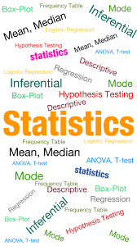  “Advanced Statistics” | Statistics in DataScience :  Statistics is used to process complex problems in the real world so that Data Scientists and Analysts can look for meaningful trends and changes. Data Science includes techniques and theories extracted from statistics, computer science, and machine learning.

By: Shubhank Katarey

Statistics is used to process complex problems in the real world so that Data Scientists and Analysts can look for meaningful trends and changes. Data Science includes techniques and theories extracted from statistics, computer science, and machine learning.
By: Shubhank Katarey

By: Shubhank Katarey

Business Report on Advanced Statistics

Course Name: PGP-DSBA (Online)

Module Name: Advanced Statistics

Submitted by: Shubhank katarey

Submission Date: 16 May 2021

Table of Contents:

Problem 1A
- Problem Statement
- Summary of the problem
- Loading the data
- Head of the dataset
- Tail of the dataset
- Five number summary
- Information about the data

State the null and the alternate hypothesis for conducting one-way ANOVA for both Education and Occupation individually.

Perform a one-way ANOVA on Salary with respect to Education. State whether the null hypothesis is accepted or rejected based on the ANOVA results.

Perform a one-way ANOVA on Salary with respect to Occupation. State whether the null hypothesis is accepted or rejected based on the ANOVA results.

Problem 1B:

What is the interaction between two treatments? Analyze the effects of one variable on the other (Education and Occupation) with the help of an interaction plot.[hint: use the ‘point plot’ function from the ‘seaborn’ function]

- Analyzing the effects of one variable on the other (Education and Occupation) with the help of an interaction plot.

Perform a two-way ANOVA based on Salary with respect to both Education and Occupation (along with their interaction Education*Occupation). State the null and alternative hypotheses and state your results. How will you interpret this result?

Problem 2

- Problem Statement

Perform Exploratory Data Analysis [both univariate and multivariate analysis to be performed]. What insight do you draw from the EDA?

- Head of the data
- Info about the dataset
- Describing the data/Five number summary
- Checking the null values
- Checking the zeros
- Numerical data

- Distribution and the Boxplots
- Pair plot
- Correlation Matrix
- Scaled Data

Comment on the comparison between the covariance and the correlation matrices from this data [on scaled data].

- Covariance matrix

- Correlation matrix

Check the dataset for outliers before and after scaling. What insight do you derive here? [Please do not treat Outliers unless specifically asked to do so]

- outliers in the dataset before scaling

- outliers in the dataset after scaling

Extract the eigenvalues and Eigen vectors [print both]

- Eigen values
- Eigen vectors

Perform PCA and export the data of the Principal Component (eigenvectors) into a data frame with the original features.

Bartlett’s Test of Sphericity:

Performing KMO Test

- Percentage variance explained by Eigen values
- Cumulative values explained by Eigen values

- Scree Plot
- PCA components

Consider the cumulative values of the eigenvalues. How does it help you to decide on the optimum number of principal components? What do the eigenvectors indicate?

*****

Problem 1A:

Problem Statement:

Salary is hypothesized to depend on educational qualification and occupation. To understand the dependency, the salaries of 40 individuals [SalaryData.csv] are collected and each person’s educational qualification and occupation are noted. Educational qualification is at three levels, High school graduate, Bachelor, and Doctorate. Occupation is at four levels, Administrative and clerical, Sales, Professional or specialty, and Executive or managerial. A different number of observations are in each level of education – occupation combination.
[Assume that the data follows a normal distribution. In reality, the normality assumption may not always hold if the sample size is small.]

Summary of the Problem:
In the dataset named ‘SalaryData’, the information is collected of 40 individuals about their educational qualification and occupation. To understand the dependency, their salary information is also noted. The collected data has 3 levels of educations and 4 levels of occupation.
We need to perform hypothesis testing on this dataset or the population and also need to do analysis on the data to get the dependency on dependent variable ‘Salary’.

Head of the data:
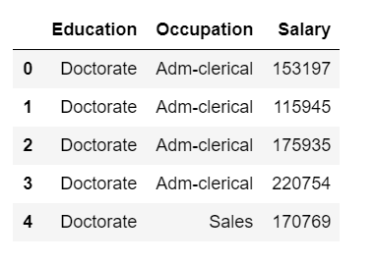
There are 3 columns: Education, Occupation and Salary.

Tail of the data:
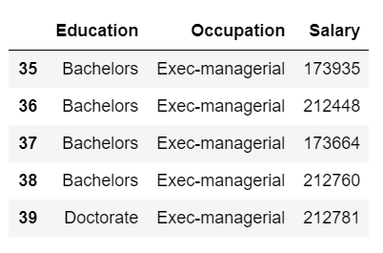

Describe the data:
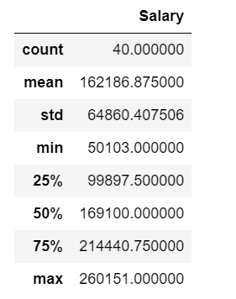
We can see five number summary and various other information about the data like max, min, 75%, 50%, standard deviation…

Information about the data:
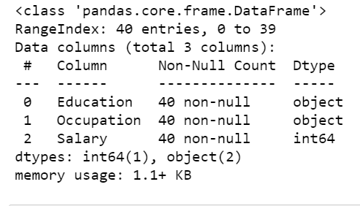
We can see information like data types, non-null counts, RangeIndex…

State the null and the alternate hypothesis for conducting one-way ANOVA for both Education and Occupation individually.

Answer:

Null and Alternate hypothesis for Education:

Null Hypothesis (H0): The mean salary of all the 40 individuals is equal at all education level.

Alternate Hypothesis (Ha): The mean salary of all the 40 individuals are different for atleast one kind of education.

Null and Alternate hypothesis for Occupation:

Null Hypothesis (H0): The mean salary of all the 40 individuals is equal for all kind of Occupation.

Alternate Hypothesis (Ha): The mean salary of all the 40 individuals are different for at least one kind of Occupation.

Perform a one-way ANOVA on Salary with respect to Education. State whether the null hypothesis is accepted or rejected based on the ANOVA results.

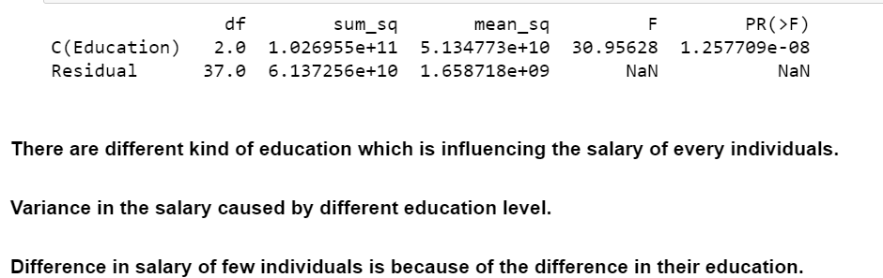

So now, we can see that the p-value is less than the significance level(0.05), hence we can reject the null hypothesis and conclude that the mean salary is different for at least one of the individual.

Perform a one-way ANOVA on Salary with respect to Occupation. State whether the null hypothesis is accepted or rejected based on the ANOVA results.

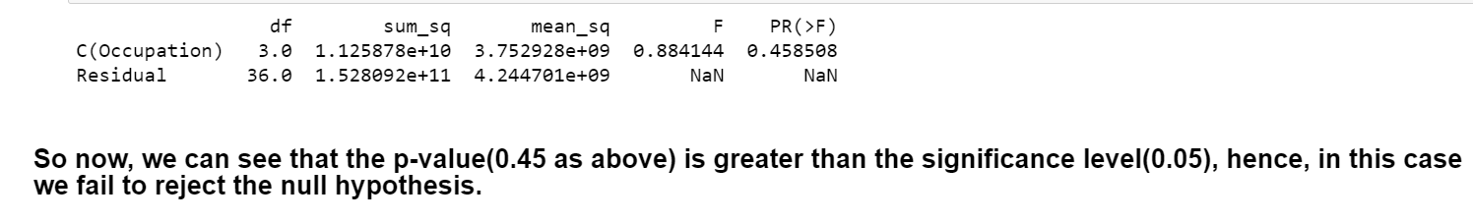

Problem 1B:

Q1. What is the interaction between two treatments? Analyze the effects of one variable on the other (Education and Occupation) with the help of an interaction plot.[hint: use the ‘point plot’ function from the ‘seaborn’ function]

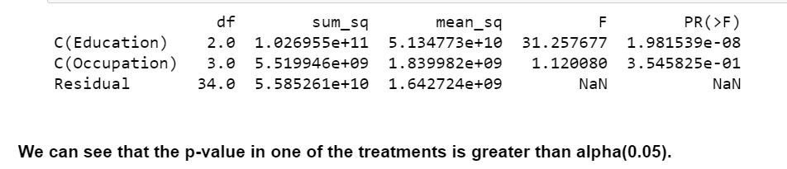

Analysis of the effect of occupation on education:
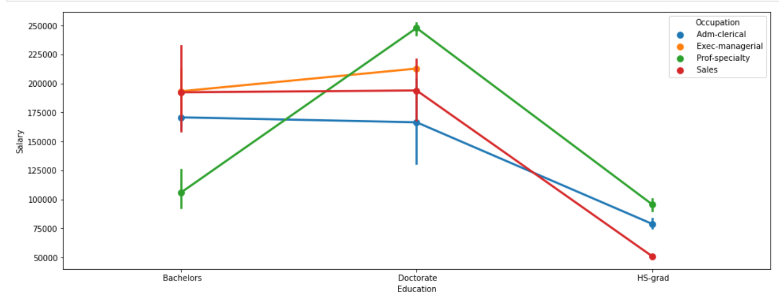
From the above plot we can see that the salary is high of the individuals of doctorate having the occupation of their profession or specialty. And the salary is lowest if the higher secondary educated individual is in the occupation of sales.

Analysis of the effect of education on occupation:
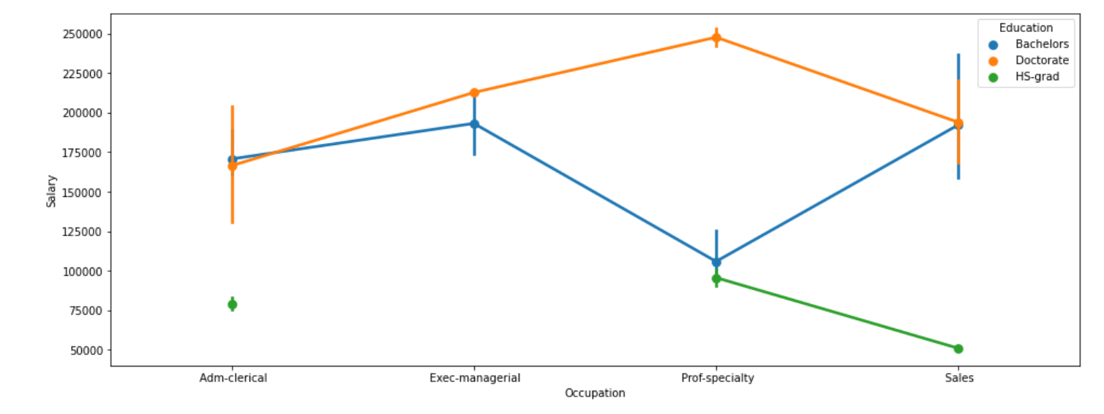
Effect of education on Salary: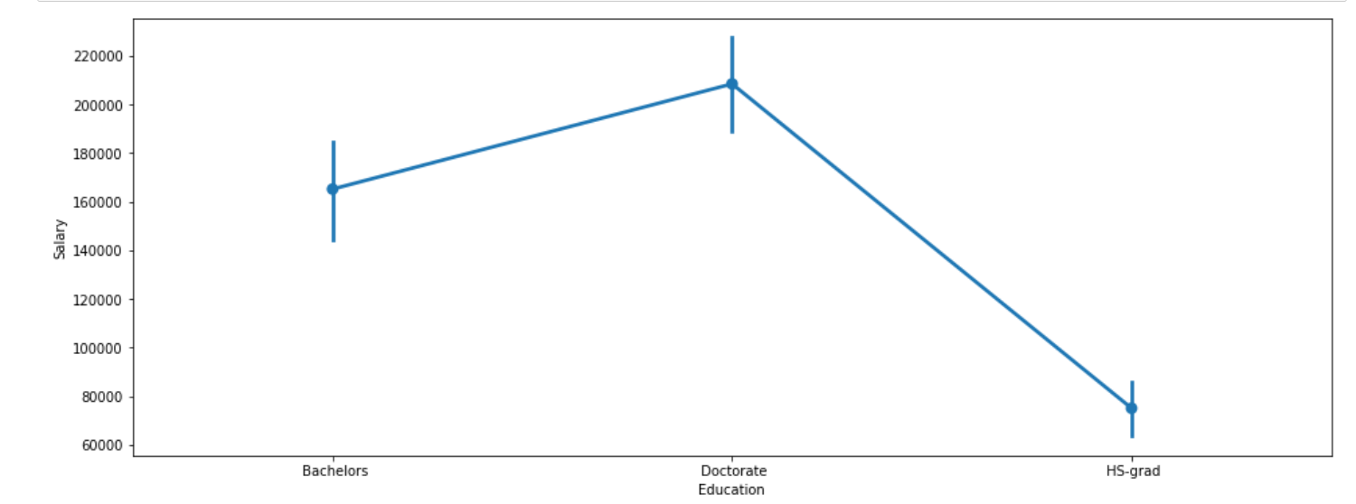Higher secondary graduate has the lesser salary than the doctorate and bachelors.
Doctorate has the highest salary.

Effect of Occupation on Salary:
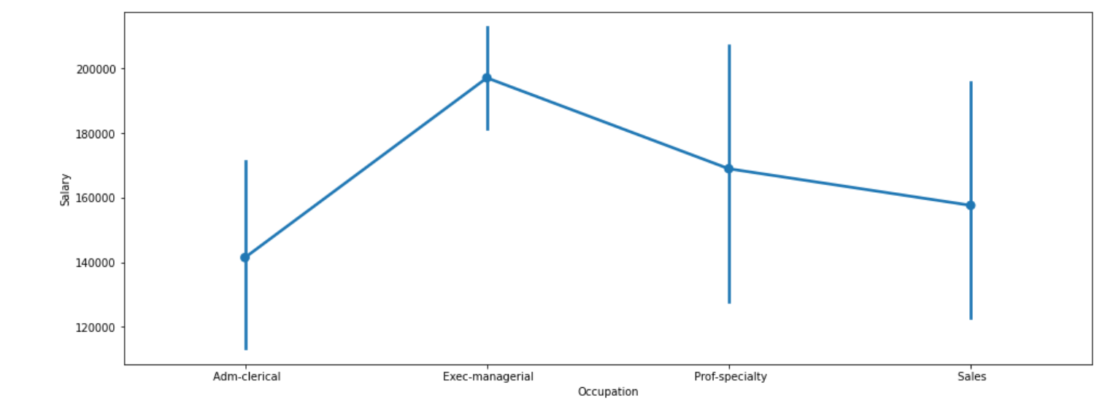

We can see that exec-managerial occupation has the highest salary.

Perform a two-way ANOVA based on Salary with respect to both Education and Occupation (along with their interaction Education*Occupation). State the null and alternative hypotheses and state your results. How will you interpret this result?
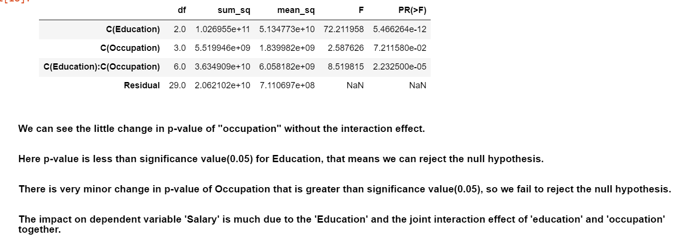

Explain the business implications of performing ANOVA for this particular case study.

Answer:

The impact on dependent variable 'Salary' is much due to the 'Education' and the joint interaction effect of 'education' and 'occupation' together.

The combined effect of education and occupation together makes a great impact on individuals salary.

Problem 2:

The dataset Education - Post 12th Standard.csv contains information on various colleges. You are expected to do a Principal Component Analysis for this case study according to the instructions given. The data dictionary of the 'Education - Post 12th Standard.csv' can be found in the following file: Data Dictionary.xlsx.

Perform Exploratory Data Analysis [both univariate and multivariate analysis to be performed]. What insight do you draw from the EDA?

Head of the dataset:
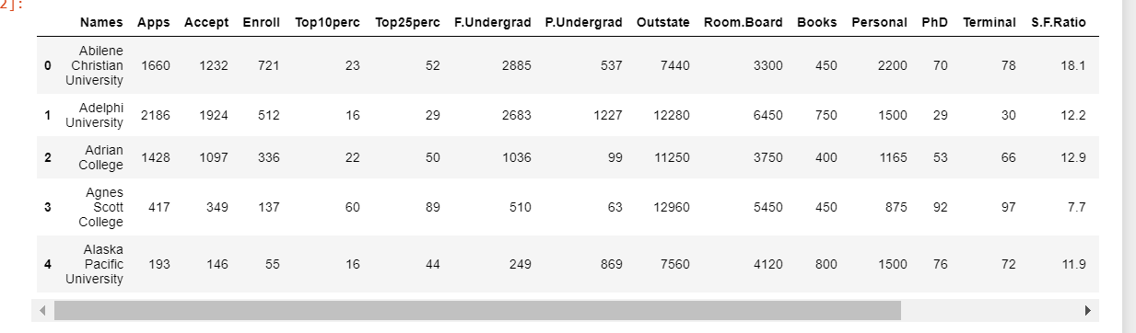
Info about the data:
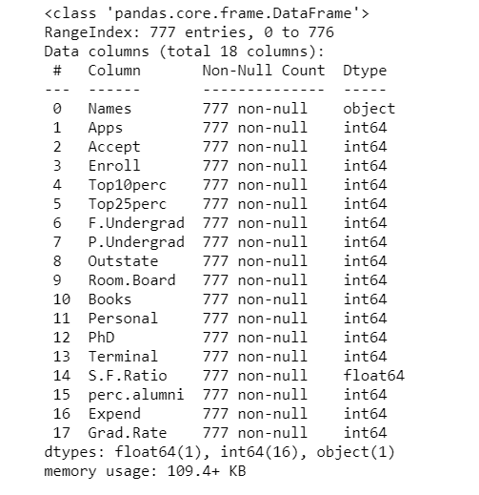
As we can see that there are 777 non-null rows, 1 column of object data type, 1 column of float data type and 16 columns of integer data type in the dataset.

Description of the dataset:
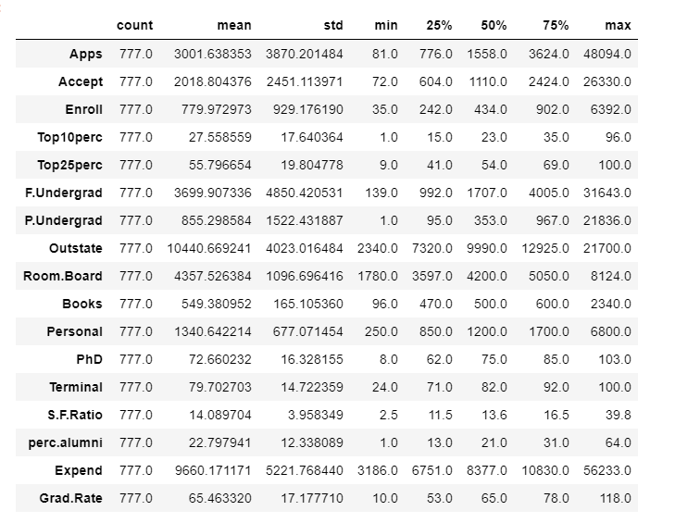

Observation:

1. Minimum No. of applications received are 81 and the maximum are 48094

2. Minimum No. of applications accepted are 72 and the maximum are 26330

3. Mean cost for room and board comes out to be 4357 rupees.

4. Maximum cost of the books for a student is 2340 rupees.

Count of Null values:
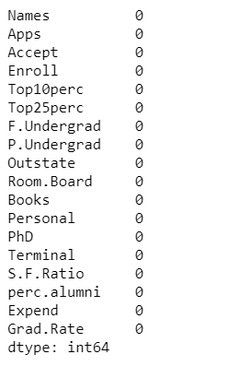

As we can see that there are no missing values in the dataset.

Count of zeros in the columns:
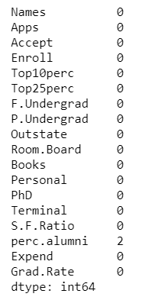
As we can see that, only 'perc.alumni' column has 2 zeros.
Dataset of Numerical columns for further analysis:
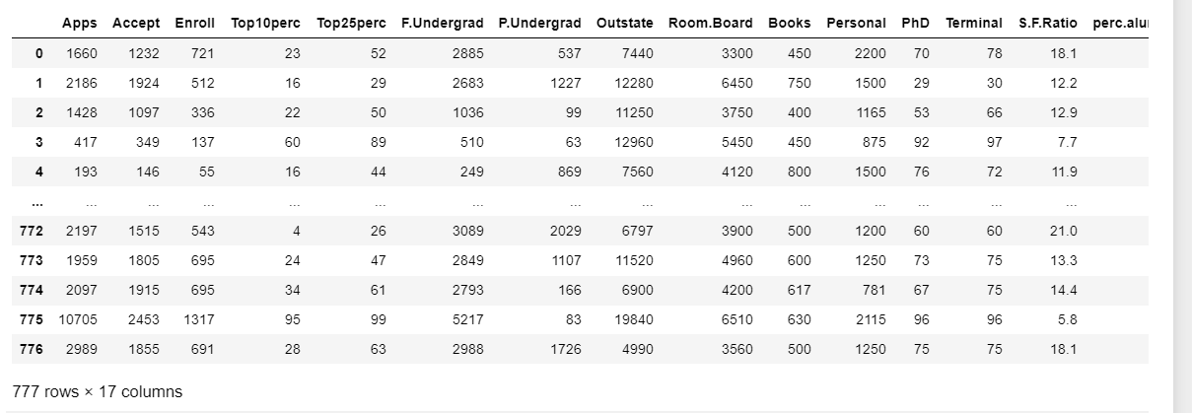
Removed the columns other than numerical (integer and float data types) values for further analysis of the data.

Distribution and Boxplots of the Numerical columns of the dataset:
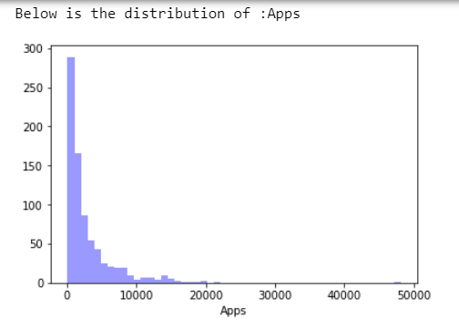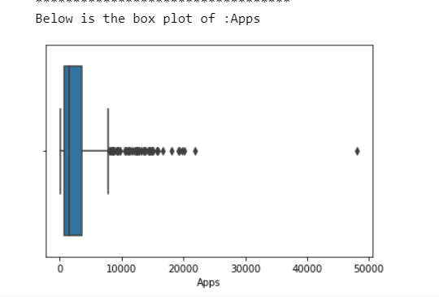
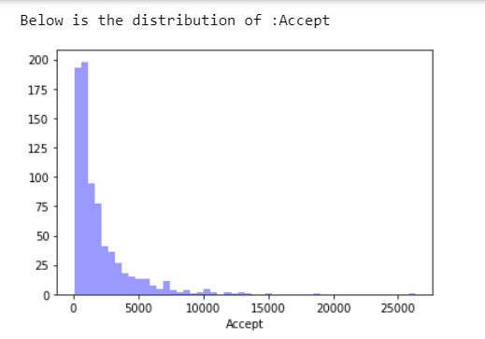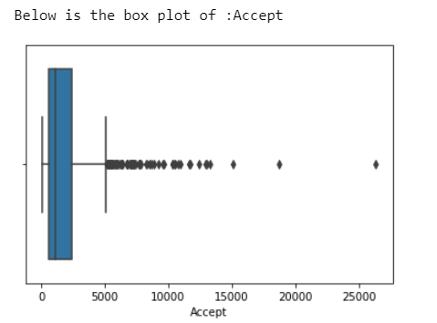
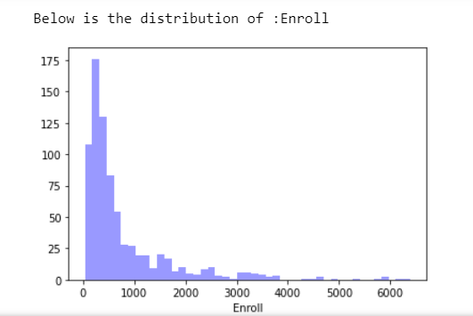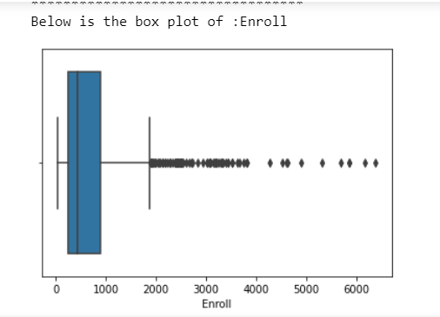
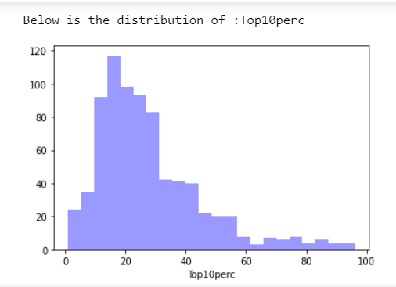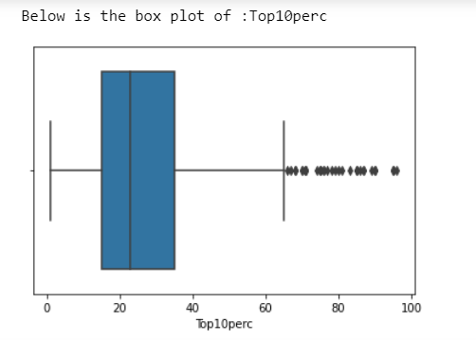
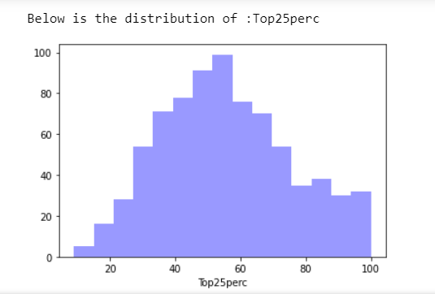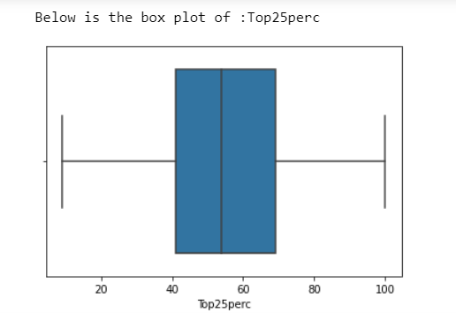

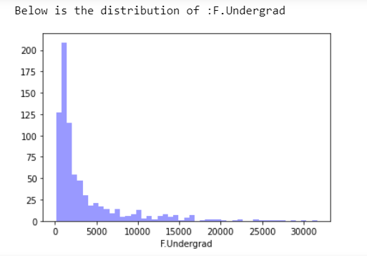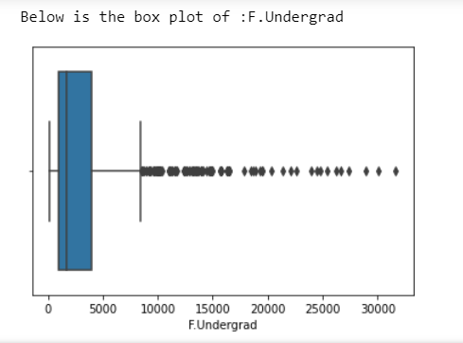

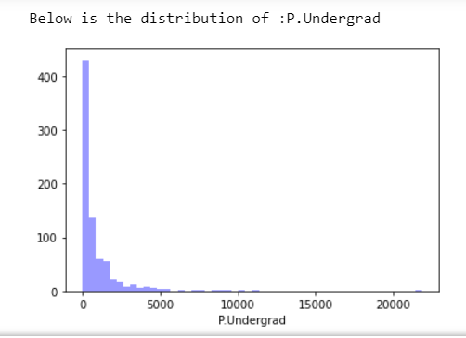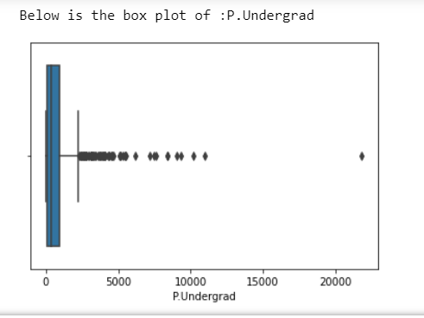

Correlation matrix :
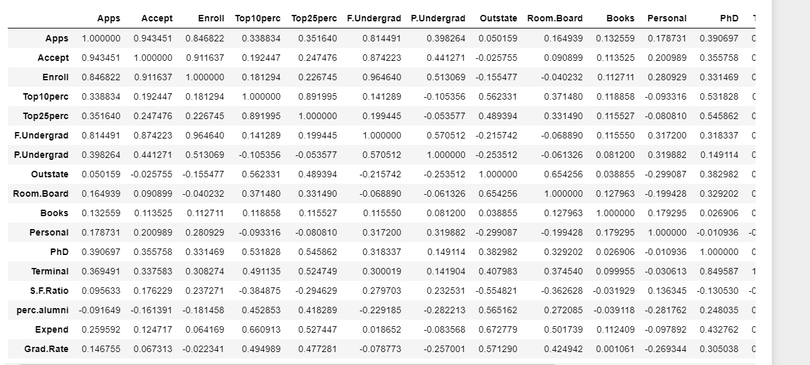

Scaled Data:
Most of the time, the variables present in the data are of different scales, for example one variable having 4 digits of numeric values and other having single digit. So, it becomes difficult to compare these variables. That's why we use feature scaling to standardize the range of features of data. It is very important step. In this method, we convert different scales of measurement into single scale. We will use zscore to normalize the data (only for numerical data).

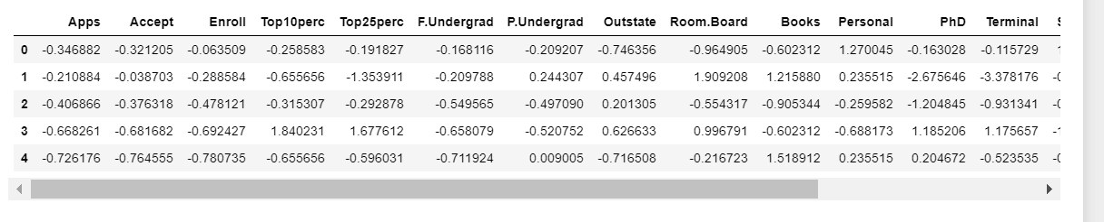

Comment on the comparison between the covariance and the correlation matrices from this data [on scaled data].
Correlation is a measure used to represent how strongly two random variables are related to each other. It is basically the scaled form of covariance.
Covariance is nothing but a measure of correlation. Covariance indicates the direction of the linear relationship between variables.
In our below correlation matrices we can see the correlation between all the 17 variables in the dataset but in covariance it is linear relationship between variables.

Check the dataset for outliers before and after scaling. What insight do you derive here? [Please do not treat Outliers unless specifically asked to do so]
Outliers before scaling:
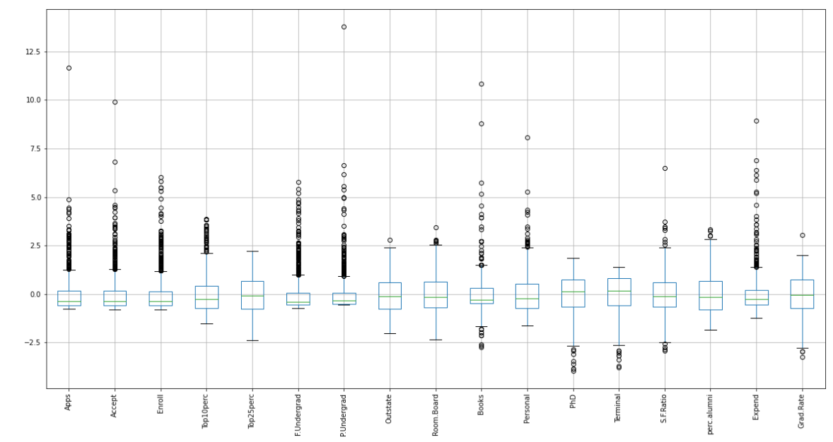
Outliers after scaling:
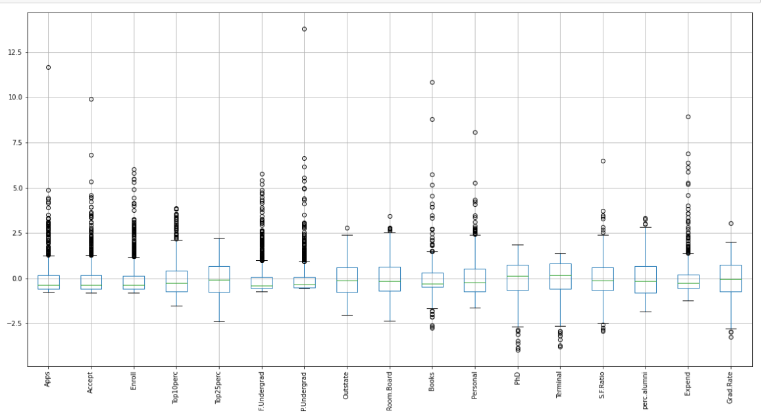
Outliers are present in the data. We can see clearly the difference after the scaling of the data. Now every variable is showing on single scale.

Extract the eigenvalues and eigenvectors. [Print both]
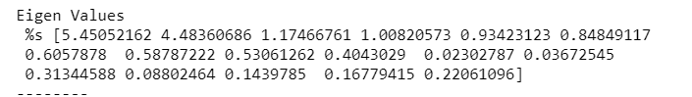
Eigen Vectors:
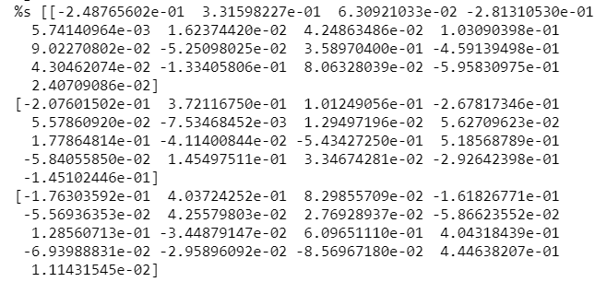

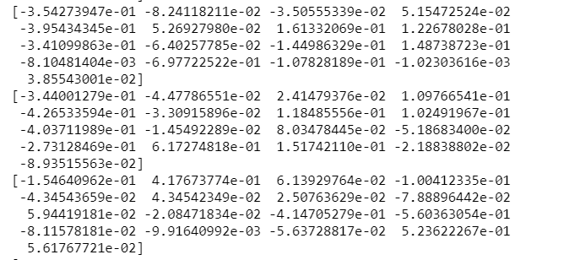
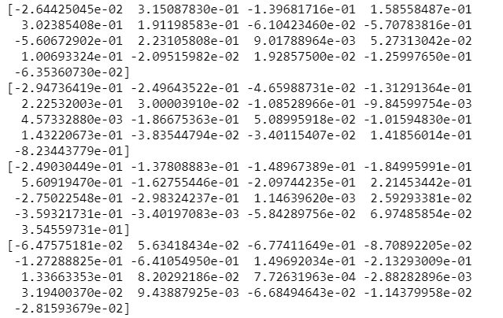
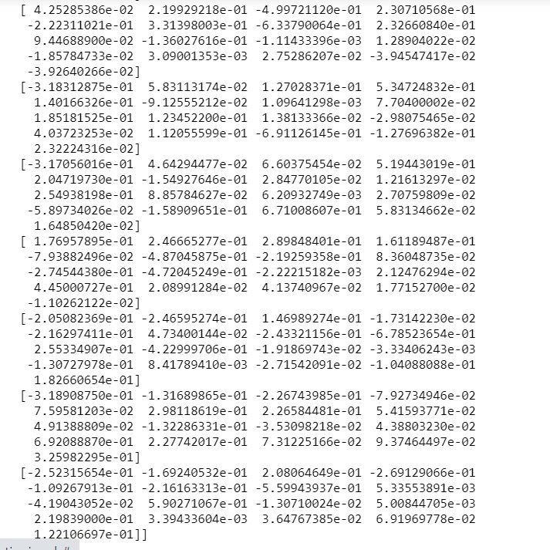

Perform PCA and export the data of the Principal Component (eigenvectors) into a data frame with the original features.

Bartlett’s Test of Sphericity:
Bartlett's test of sphericity tests the hypothesis that the variables are uncorrelated in the population.
H0: All variables in the data are uncorrelated.
Ha: At least one pair of variables in the data are correlated.
If the null hypothesis cannot be rejected, then PCA is not advisable.
If the p-value is small, then we can reject the null hypothesis and agree that there is at least one pair of variables in the data which are correlated hence PCA is recommended.

Here, we can see that the p-value is small (0.0), so now we can reject the null hypothesis and agree that there is at least one pair of variables in the data which are correlated hence PCA is recommended.

Performing KMO Test:
Measure of sampling adequacy (MSA) is an index used to examine how appropriate PCA is.
If MSA is less than 0.5, PCA is not recommended, since no reduction is expected.
But if the MSA > 0.7 then it is expected to provide a considerable reduction in the dimension and extraction of meaningful components.

0.8131251200373524

Here we can see that, MSA is 0.81 and that is greater than 0.7, so it is expected to provide a considerable reduction in the dimension and extraction of meaningful components.

Scree Plot: To get the number of components to be built.

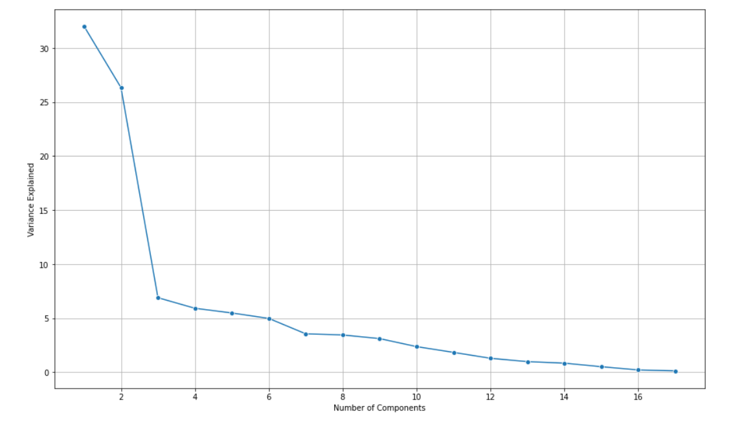
We will take 6 PCA dimensions out of 17, because after that point, there is a continuous decline in the variance as displaying in the above scree plot.

Importing PCA from sklearn.decomposition and applying fit.transform to the scaled data:

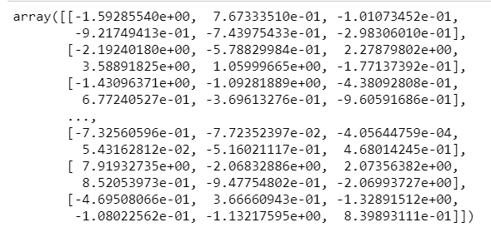

PCA Components:

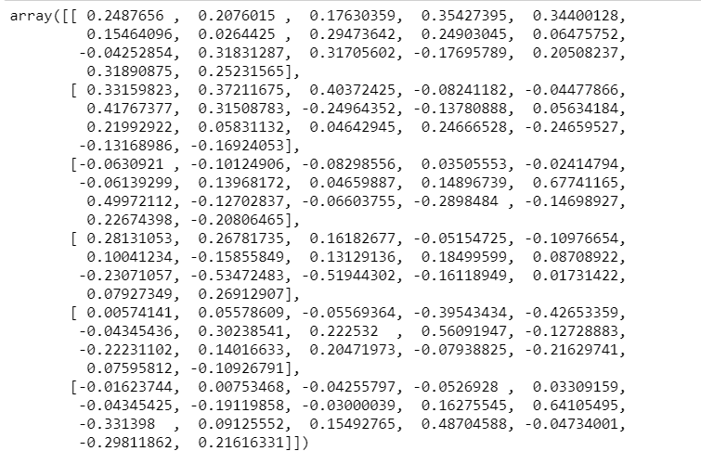

Write down the explicit form of the first PC (in terms of the eigenvectors. Use values with two places of decimals only).

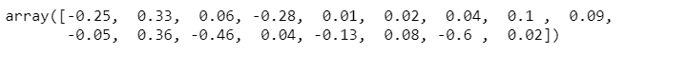
Above is the explicit form of first PC (in terms of eigenvectors) with 2 decimal places only.

Consider the cumulative values of the eigenvalues. How does it help you to decide on the optimum number of principal components? What do the eigenvectors indicate?

